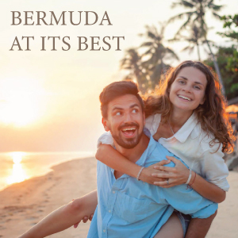

**BLOG 1  
Bermuda at Its Best**

**http://bit.ly/2PD7HeM**

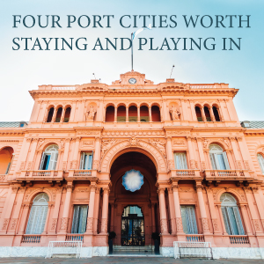

**BLOG 3**

**Four Port Cities Worth**

**Staying and Playing in**

**http://bit.ly/2WfOzpR**

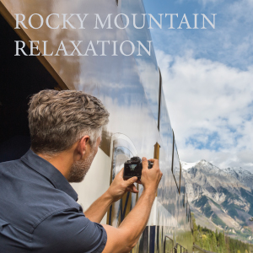

**BLOG 2  
Rocky Mountain Relaxation**

**http://bit.ly/2GInMvP**

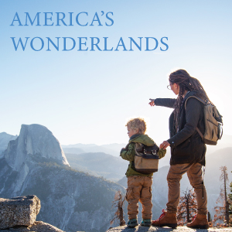

**BLOG 4  
America’s Wonderlands**

**http://bit.ly/2PAYQdH**